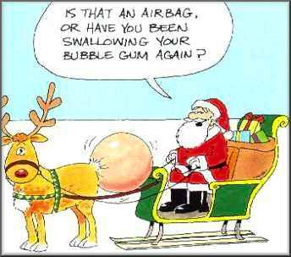

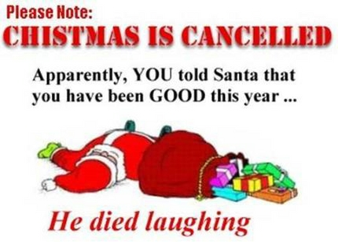


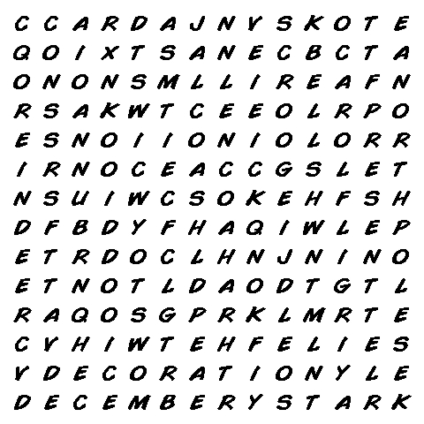 |  |  |  |   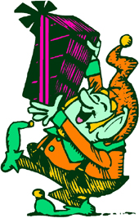
Find These Words:  bells  candy cane  card  carol  cookies and milk | December  decoration  frost  holly  hot chocolate  icicle | North Pole  present  reindeer  Rudolph  Santa  Scrooge | sleigh  snowflake  snowman  star  stocking  tree

This Christmas I want _____________________________
______________________________________________


Christmas Cloze
Fill in the blanks with words from the box:
checks  naughty  North Pole  lap  cards  sleigh  coal | nice  beard  decorate  baked  presents  holiday  toys | sing  Boxing  elves  turkey  under  reindeer  merry | fills  Eve  workshop  lights  chimney  family  spirit

Christmas:
Christmas is a _________________ when people get together with _________________. People give _______________ to each other or send ____________________ wishing each other a _________________ Christmas. At Christmas, people ____________ carols to get into the Christmas _______________. As well, people ______________ Christmas trees and put up ________________ around the house. A common Christmas dinner is ______________. There are also lots of ________________ goodies for the kids. Christmas begins on the day before Christmas, or Christmas _________________ and continues until _______________ Day, when many people go shopping for sales.

Santa Claus:
Santa Claus is an old man with a white _________________ that lives at the __________________. Children sit on Santa’s _________________ and tell him what they want for Christmas. Santa _________________ his list to see if the children have been _________________ or _________________. If the children are bad Santa brings them __________________. If the children are good Santa brings them ____________________. The toys are made in Santa’s
___________________ by _________________. Santa travels around the world in his _________________, which is pulled by flying ___________________. When he stops at a house, he goes down the __________________ and puts presents _________________ the tree and then he _________________ the stockings. | 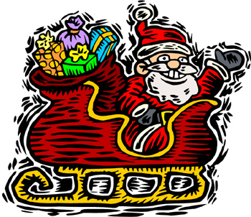

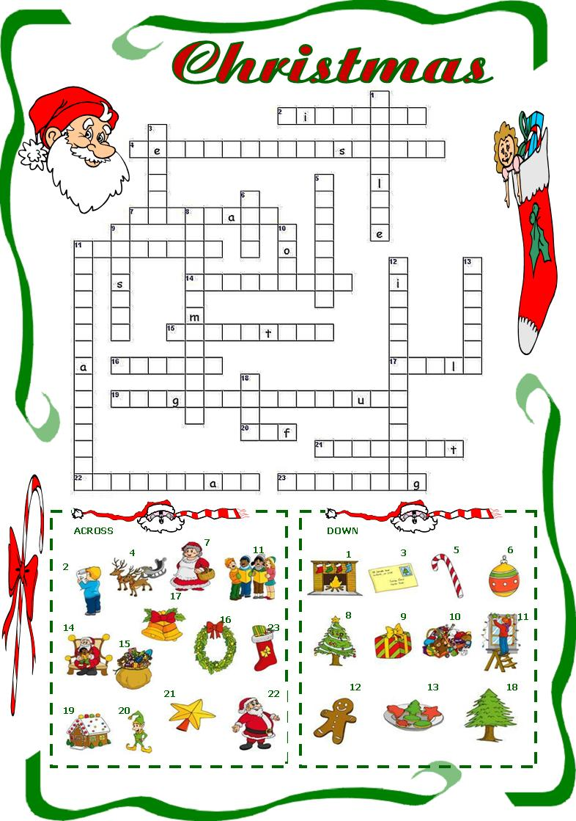

Something you give that rhymes with lift.  Something you send that rhymes with hard.  A little helper that rhymes with shelf.  Something striped that rhymes with rain.  A famous reindeer that rhymes with golf.  Something you sing that rhymes with barrel. |  | 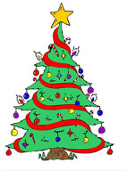
Something you decorate that rhymes with bee.

Something you hang that rhymes with rocking.

This covers the window and rhymes with lost.

What you put on your roof that rhymes with fights.

What Santa drives that rhymes with hay.

This holds Santa’s presents and rhymes with back.

 | Something you ring that rhymes with well.  Green leaves that rhyme with golly.  Where Santa lives that rhymes with hole.  An old miser who rhymes with stooge.

 | 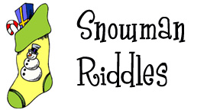 |  |  |  | Name: ___________________________  Unscramble the snowmen to find clues to solve the snowmen riddles at the bottom of the sheet.
 | 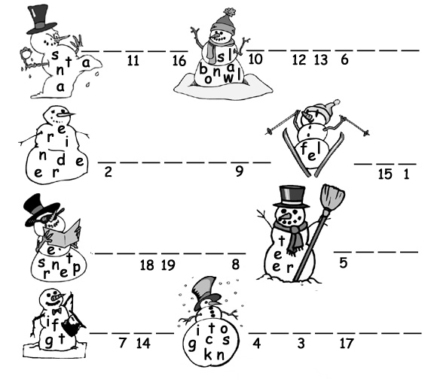
 | Riddle 1: What do vampires get when they attack snowmen?
 | 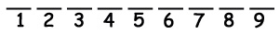
 | Riddle 2: What do snowmen eat for breakfast?
 | 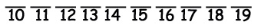
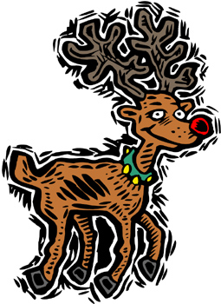
 |  |  | How many words can you make out of Rudolph’s Red Nose?

R U D O L P H’ S

R E D N O S E
 |  |  |  | ___________ |  |  |  | ___________
 |  |  |  | ___________ |  |  |  | ___________
 |  |  |  | ___________ |  |  |  | ___________
 |  |  |  | ___________ |  |  |  | ___________
 |  |  |  | ___________ |  |  |  | ___________
 |  |  |  | ___________ |  |  |  | ___________
 |  |  |  | ___________ |  |  |  | ___________
 |  |  |  | ___________ |  |  |  | ___________
 |  |  |  | ___________ |  |  |  | ___________
 |  |  |  | ___________ |  |  |  | ___________
 |  |  |  | ___________ |  |  |  | ___________

Did you find?
 |  | A place that sells things.
 |  | A place to swim.
 |  | A place to live.
 |  | Yours and mine.
 |  | The opposite of he.
 |  | The opposite of over.
 |  | Animals that live in a flock.
 |  | Something to write with.
 |  | Something to eat soup with.
 |  | Something to measure with.
 |  | A great person.
 |  | A long, skinny fish.
 |  | A long, thick string
 |  | Something you plant.

DO THEY KNOW IT'S CHRISTMAS TIME 2004 (as Band Aid 2004)
It's Christmastime
There's no need to be (1)……….
At Christmastime, we let in (2)……….. and we banish shade
And in our world of plenty we can spread a (3)………… of joy
Throw your arms around the (4)………… at Christmastime
But say a prayer
Pray for the other ones
At Christmastime it's hard, but when you're having (5)…….
There's a world outside your (6)………….
And it's a (7)……………. of dread and fear
Where the only (8)………….. flowing is the bitter sting of tears
And the Christmas (9)……….. that ring there are the clanging
chimes of doom
Well tonight thank God it's them instead of (10)……….
And there won't be (11)………… in Africa this Christmastime
The greatest (12)……… they'll get this year is life
(Oooh) Where nothing ever grows
No (13)……. nor (14)……….. flow
Do they know it's Christmastime at all?
(Here's to (15)……) raise a (16)………. for everyone
(Here's to (17)……..) underneath that burning (18)……..
Do they know it's Christmastime at all?
Feed the world
Feed the world
Feed the world
Let them know it's Christmastime again
Feed the world
Let them know it's Christmastime again
repeat then fade

All I want for Christmas – Mariah Carey
I don't want a lot for Christmas
There's just one thing I need
I don't care about the 1…………..
Underneath the Christmas tree
I just want you for my own
More than you could ever know
Make my wish come 2……………...
All I want for Christmas
Is you...
I don't want a lot for Christmas
There is just one thing I need
I don't care about the presents
Underneath the Christmas tree
I don't need to hang my stocking
There upon the 3………………
Santa Claus won't make me happy
With a 4…………. on Christmas day
I just want you for my own
More than you could ever know
Make my wish come true
All I want for Christmas is you...
You baby
I won't ask for much this Christmas
I won't even wish for 5……………
I'm just gonna keep on waiting
Underneath the 6…………………….
I won't make a list and send it
To the North Pole for Saint Nick
I won't even stay awake to
Hear those 7………… reindeer click
'Cause I just want you here tonight
Holding on to me so tight
What more can I 8……………..
Baby all I want for Christmas is you
You...

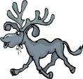

All the lights are shining
So brightly everywhere
And the 9…………. of children's
Laughter fills the air
And everyone is singing
I hear those sleigh bells ringing
Santa won't you bring me the one I really need -
won't you please bring my baby to me...
Oh I don't want a lot for Christmas
This is all I'm asking for
I just want to see my baby
Standing right outside my 10……….
Oh I just want him for my own
More than you could ever know
Make my wish come true
Baby all I want for Christmas is
You...
All I want for Christmas is you baby... (repeat)

Assignment 1
Luister naar het liedje All I want for Christmas van Mariah Carey en vul de ontbrekende woorden in.

Assignment 2
Beantwoord de volgende vragen in het Nederlands.

1: Waar gaat dit liedje over?

2: Wat weet je allemaal van de Amerikaanse manier van kerstmis vieren?

3: Wat is een mistletoe?

4: Wat zou jij graag van Santa Claus willen hebben voor kerst?

5: Wat vind je van dit liedje?

